**Step1**: Install Python

**Step2**: Install Jupyter Notebook for Python

**Step3**: Unzip the code .rar file shared. After unzip you will be able to see following folders

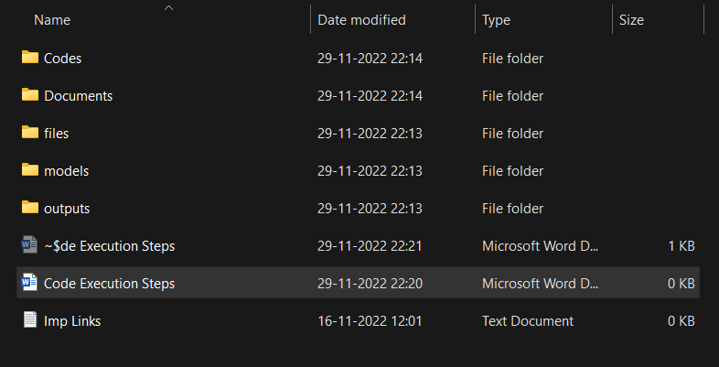

Code Folder: Has code files for all models

Documents Folder: Has final presentation documents

Files Folder: Has all the input data files for running models

Models Folder: This is the repository for saving final models

Outputs Folder: Folder to store intermediate files generated during modelling process

**Step4**: In Windows open command prompt

**Step5**: Navigate to “Codes” folder present inside unzipped project folder (using cd command)

**Step6**: Run jupyter notebook from the navigated location using “Jupyter notebook” command

If above steps are successfully executed you should be able to see an browser window launch having model code for all the 3 model implementations

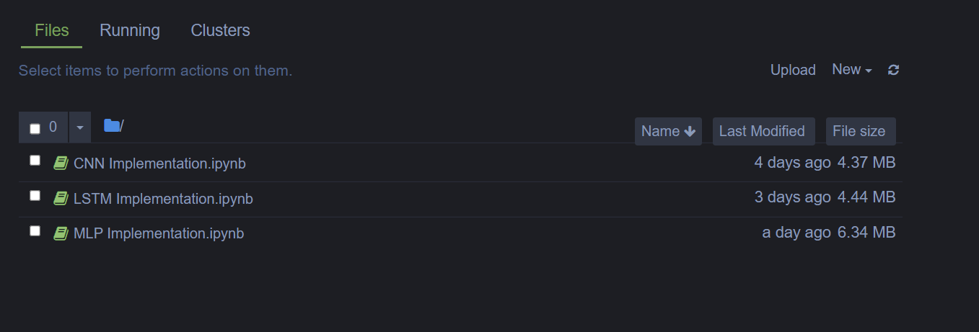

**Step7**: By clicking on the file name displace in the browser you should be able to open and run code with ease